**Our successful Pathway to Work scheme**

Wirral-based charity Autism Together opened its Pathway to Work scheme in October 2023.

The aim of the project is to create a formal route for those autistic adults we support who would like to join the world of work.

It was recognised that a number of individuals within our Day Services had developed the requisite work skills and experience, through the person-centred support they had received, working in one of our public-facing services – the charity runs three cafes with the people we support helping to serve customers and working behind-the scenes.

These individuals were ready, and, if they wished to, could take that next step into work in the wider community, with less support from us.

We recognised that, while this would be an amazing opportunity, there were potential barriers for some autistic adults, such as:

* Fear of change.
* Loss of a fully-structured week.
* Families fear of change and failure for the individual.
* Understanding of autism in the workplace and support needs.
* Travel to the work location.
* Pre-conceptions of what work involves (hours/location/tasks).
* Traditional interviewing and application methods.

Pathway to Work aimed to reduce these barriers by bridging the gap between Day Services and employment for people we support. It provides individuals with a route into employment, while still remaining under the Autism Together umbrella, meaning that if things don’t work out, the individual can come back and rejoin our services.

Our programme works by helping each individual make a gradual transition from Day Services into a community-based work placement, with the overall aim to replace all days on Day Services with work in the community.

Each person is supported by our Pathway to Work Coordinator, Mark White, in a flexible, person-centred way – through visits, phone calls and video calls. These days would remain funded by social services but charged for at a reduced rate (less than half of their previous placement cost).

This has a number of benefits, such as increased independence and self-esteem for the individual, while the local authority in Wirral sees a reduction in reliance on funded services and a step towards their All Age Disability Strategy goal that: ‘*all young people and adults with disabilities have access to employment and are financially resilient*’.

**The implementation of Pathway the Work**

The introduction of the Pathway to Work as a separate stream of day services, coincided well with the remodelling of our Day Services to include different streams to match individuals’ interests, with a focus on the development of individuals through a ‘Support Journey’ which our ethos for support is based upon.

We currently have five individuals on our Pathway to Work programme, with each volunteering between 1 and 3 days a week at various locations, including a local vet surgery, Café Number 7, Make It Happen CIC, Autism Together’s Estates Department, and a YMCA charity shop.

Three more people have been identified to begin the Pathway to Work in the coming months.

All the individuals on the Pathway were originally being supported in our Day Services and funded by Wirral Social Services. The cost saving to Wirral Council is around £21k per annum.

**What have we learnt?**

We have learnt that many of the barriers identified at the outset, are still barriers to individuals. But, seeing others achieve success has encouraged confidence and interest in the scheme from a wider range of people we support.

We have discovered other barriers – such as individuals being very comfortable in their current routines, and therefore not wanting to change or progress.

Another new barrier we have discovered is individuals’ rigidity in their thought process about their ideal employment, for example, someone wanted to drive double decker buses, but they have struggled to change their ideal, towards other potential driving jobs.

We have learnt that it is much easier to obtain work placements in areas such as charities and CICs. These areas are more aware and welcoming to individuals with differences and disabilities.

**Future Development of the Service**

Our aim over the next 12 months of the pathway is to double the number of days that people are accessing the service, growing it from 8 days to 16 days. This would be the maximum days we would be able to support the individuals, with our current allocated resources.

The service recently received some funding from John Lewis for projects relating to ‘Employability and Education’. This has been spent on tablets and licences for the Empowerment Passport. Developed by a local Occupational Therapist and mother of an autistic son, this is a digital platform which enables people with long-term health conditions or disabilities to think about and communicate the unique adjustments that they would need in employment.

We will also be introducing a measurement tool – to assess individuals’ confidence levels at the start of the programme and reassess this on a regular basis, to provide quantitative evidence about the success of the programme.

We also have a desire to attract more companies willing to support the journeys of the individuals on Pathway to Work by providing placement opportunities.

**Case Studies**

**Steven Parson at YMCA shop in Prenton**

One of the first successes on Autism Together’s Pathway to Work scheme is Steven Parson.

Steven gained a wide range of customer service experience working at two of the cafés run by Autism Together – at Bromborough Pool Village and Port Sunlight River Park – supported by the organisation’s staff.

Steven has been able to take this experience into the wider workplace, through a volunteering placement at a YMCA charity shop in Prenton.

Recently we visited Steven at his placement to have a chat with him and Theresa, who manages the store and is working closely with Steven.

Steven began working one-day a week at the charity shop from the start of April 2024, in which time he has been a hit with customers, due to his friendly and chatty nature. He’s also a whiz on the till!

Steven said: “So I work on the till, and I've had a couple of times when I've put the clothes out and had a little go at putting tags in the clothes and sorting them out to go out on the shop floor, which is nice. But I like the till because you get to chat to the customers.”

Theresa said: “Steven's great. He likes to do the till, and he'll help out with other things as well when we need him to. He'll chat to the customers and that. So yeah, he's great!”

Steven explains that he likes to keep himself busy, working three days a week in Autism Together’s cafes and one at the YMCA shop.

“So I have Friday off, which is good. It’s when I can catch up with my housework and things like that.”

When asked what skills Steven has picked up or improved upon since working within a busy charity shop he immediately points to customer service skills, and that he feels good to be volunteering in the community. Theresa also thinks Steven has become more confident, the longer he’s worked at the shop.

“Yeah, I was a bit shy at first,” admits Steven. “But I’m more relaxed now. I've been here quite a few weeks now, so I'm kind of settled and I like it.”

We asked Theresa why she thinks it’s important for the people we support to have opportunities to volunteer in the community, like Steven is.

“I think it helps with communication skills, definitely. Steven has come out of his shell an awful lot and chats a lot more now.

“Also, he's learned a couple of new things. So, if he wanted to apply for retail [jobs], he can use those skills he's learning – as in pricing and sorting clothes to go out, where things go merchandising-wise, he can apply those skills in any future jobs.”

Lastly, we asked Steven about his future and what work he might like to do next.

“I don't know,” he says. “I'm just quite happy doing what I'm doing for now. I'll play it by ear and see how I get on. But I just feel quite settled here now, I'm quite happy, so it's nice.”

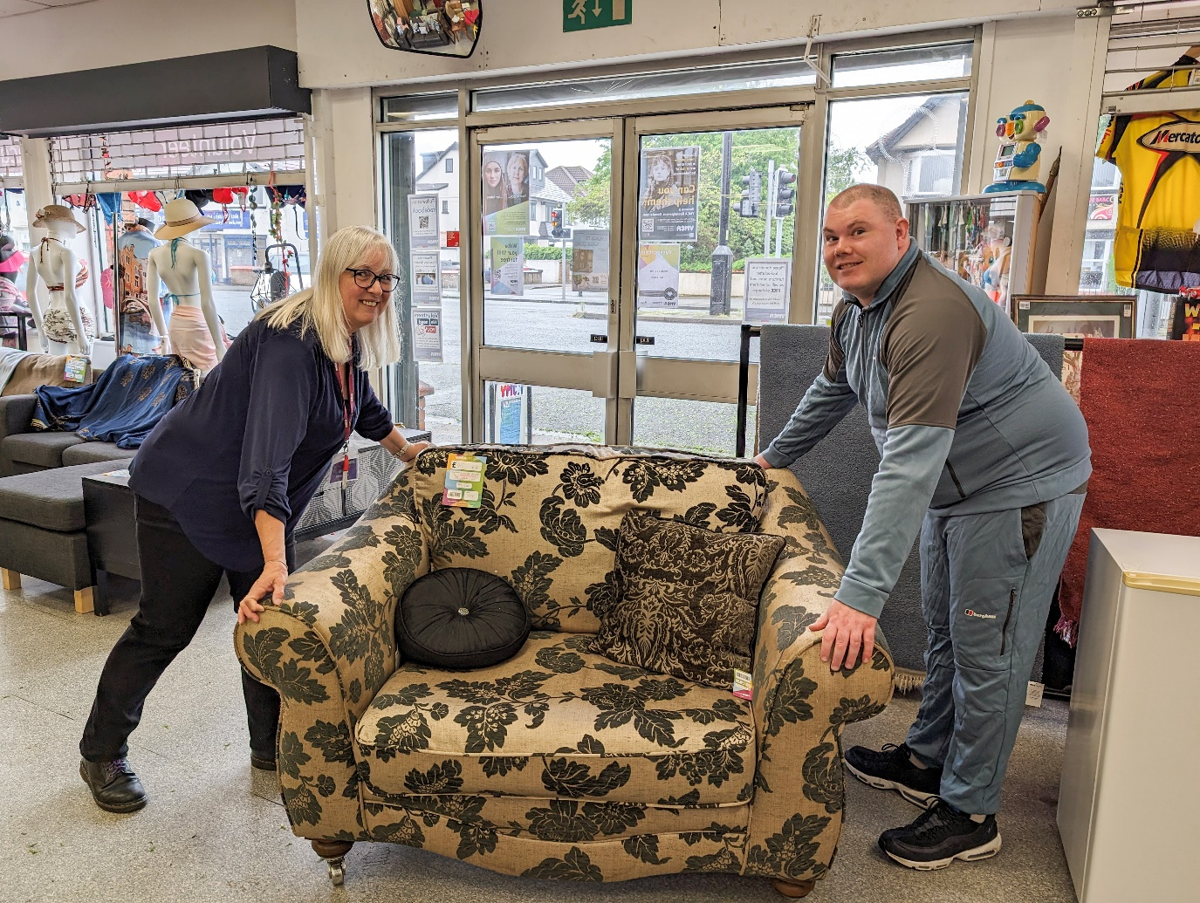

Theresa with Steven at the YMCA shop in Prenton **Chris Wood at Number Seven**

Chris Wood, one of the people we support at Autism Together, took up a placement through our Pathway to Work scheme at the start of 2024, and is thriving in his new role.

Working at Number Seven, a project in Birkenhead combining a social supermarket and café for the local community, has been a very positive and beneficial time for Chris.

Chris explains: “It's been a good experience, learning different training skills. Like the basics - taking stock, taking items and pricing them – things like that. Reducing things in the back, learning about general health and safety.

Chris works closely with Sandra, one of the volunteers at Number Seven. Sandra thinks Chris has improved in many departments, not least in his personal confidence and communication skills.

“Yeah, he's come on very well,” Sandra says. “He's got more confidence, he knows about rotation and merchandising, and he's learned a lot and is very helpful.

“I feel now I don't have to really tell him what to do, he's got himself in a routine and his communication’s great.

“We do have a nice chat now, don't we, Chris? And you know, he talks about his social things and he's really coming on. I think this project has done him really, really well.”

Chris agrees, explaining: “We’ve been a good team. If you have a good balance then you know where you’re going with the next task, which challenge you want to do next.”

Working two hours, twice a week, Chris takes us through a typical shift at the social supermarket, which offers a range of reduced goods and groceries to those in need:

“We take a delivery on Monday, so taking all the items in the stock room and using the trolley to put the items in, using the price gun.”

Sandra adds: “When we get a big delivery in, I can't lift very well so Chris is very helpful. He will help me lift the crates and then we bring in the delivery from the stock room and we bring it into the shop.

“Then we rotate it, sort it out, and we price it, and then Chris stocks up with me. He's very good at keeping the shop tidy, as you can see! Everything's brought forward and rotated - he's excellent at that. So, he's got himself in a really good routine.”

Moira McAdam, the project manager at Number Seven, was also full of praise for Chris and what he has achieved this year:

“Chris has been with us now about four months… he’s great! He just gets on with everything, he turns up on time, he does his job… And he’s just a great asset really to the team.”

Moira explains that Chris is best suited to working in the quieter supermarket side of the project rather than the bustling café area, the latter – which seats up to 46 people – can be a bit busy and potentially overwhelming to some autistic people.

“It does get busy, but if it ever does affect Chris at all, he's always got the back [space] where he could go out if he wanted. But he seems to be coping really well, and it's great to have him here.

“He’s picking up social skills. He's mixing with all the staff of volunteers and he's definitely easier around everybody now, so he's definitely picked up the social skills.

“He's attentive, he listens to what Sandra says to him, and he's just really pleasant. He's got lots of skills and hopefully we can keep building on them.

“As long as Chris wants to stay, we're happy to have Chris, as he's so good.”

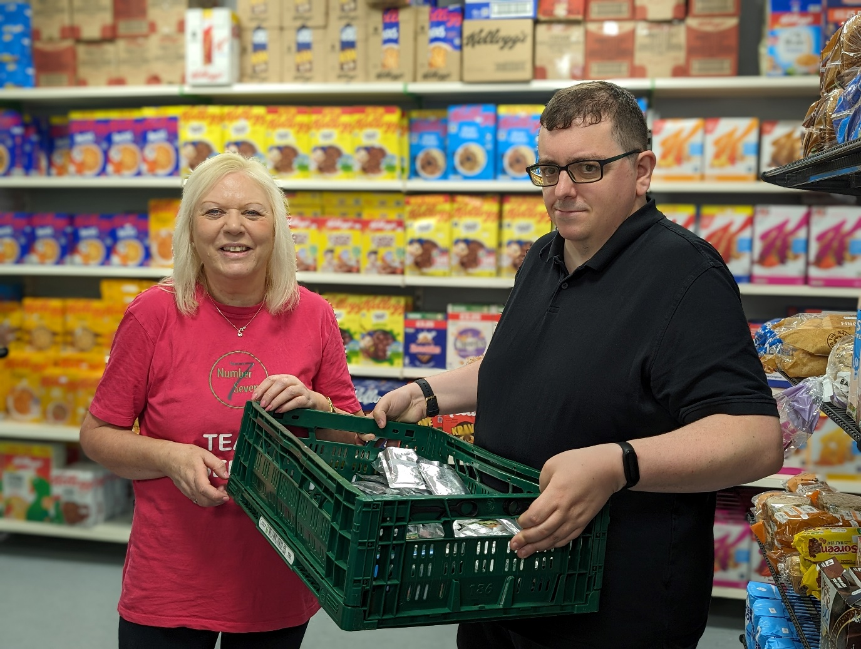

Sandra and Chris at Number Seven in Birkenhead

**Find out more about the work of Autism Together by visiting the charity’s website:** [**autismtogether.co.uk**](http://www.autismtogether.co.uk/) **or LinkedIn page:** [**uk.linkedin.com/company/autism-together**](http://uk.linkedin.com/company/autism-together)**.**